Light & Motion Vis360 Review

October 2010

While LED headlights are not NEW, the switchover from halogen or HID systems has allowed for some really cool light designs. Blazing the trail of innovative bicycle headlights is Light & Motion, who have once again created a unique light combo called the Vis360.

Created for commuters, this tiny light system offers a blinky rear light, yellow lights visible from the rider’s side and a 110 lumen front light. The flashing red strobe in back houses the rechargeable battery and two yellow side lights. Wired to this is the front light with two brighter yellow side lights and the switch to control it all. While the rear light/battery unit isn’t small by rear blinky standards, the thumb-sized front lamp emits light seemingly disproportionate to its size. Add in the fact this is all mounted on your helmet and you have a very conspicuous, effective lighting system.

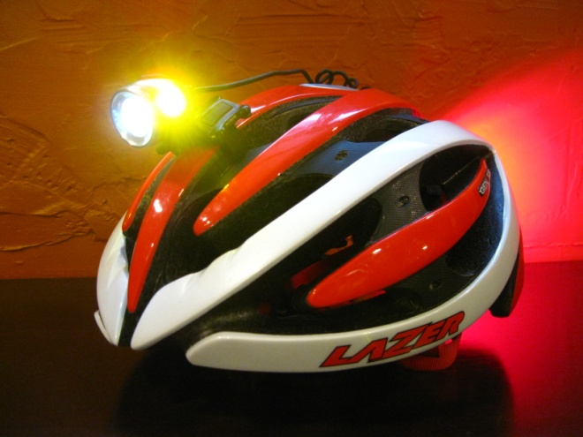

Installing the front light on a helmet is easy and Light & Motion supplies a variety of mounting options for different helmets. I worried about the mounting on the Laser helmet, with its narrow, ridged center rib, but the rubberized mount held light in place admirably. I found the rear mounting rather fiddly, however. The larger mounting plate, the Velcro strap and the pointy, uneven end of the helmets I tested conspired to aggravate me. I would think a rubberized strap (as found up front) or a ziptie would work much better. Still, once you do get it installed, you will be able to leave it in place and not have to worry about it.

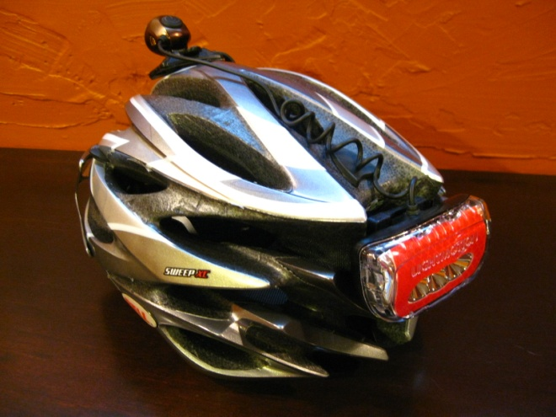

If you ride in the dark and have never had a rechargeable light “system”, you owe it to yourself to check them out. The 110 lumen headlight will feel like a cannon of light, compared to most bar-mounted, alkaline-fed headlights. Good light output gives you the confidence and visibility to ride at night or commute during the winter. The Light & Motion Vis360 outshines other options by providing significant side visibility and putting it all in a very unobtrusive package. Good things do come in small packages.

--Jef Michel