Burley Travoy Review
October 2010
I love hauling things by bike. Trailers, cargo bikes or old-fashioned stacks on racks—I love hearing comments like, “You carried all THAT on your bike?” Getting a chance to do a ride review on Burley’s new Travoy trailer seemed right up my alley.
Set-up is super simple. The frame unfolds, wheels pop on and bag is attached to any of a variety of mounting points. The minimalist hitch wraps around the seatpost and offers easy, one-handed engagement of the trailer. In mere moments you are ready to haul stuff.
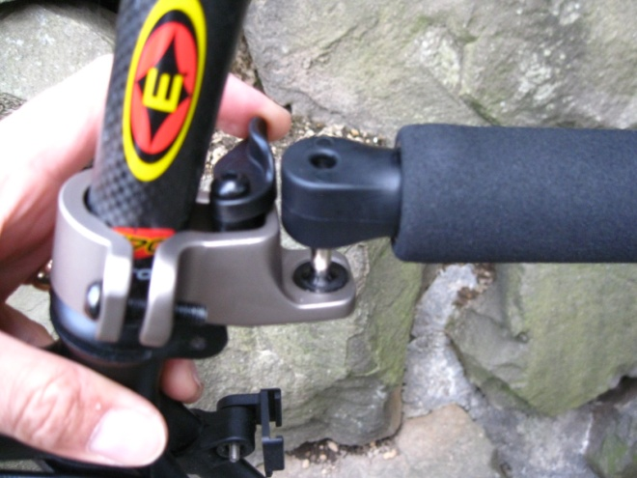
I had some donations to take to the local Goodwill and used this as a heavy duty test opportunity. The Travoy is rated at 60lbs total cargo, with 20lbs max for the included bag. A large box was held in with the included straps at the lower end of the trailer, while the cargo bag was attached to the uppermost mounts. All was good to go, but I felt it prudent to add one bungee cord around bag to ensure my (ahem) “copius” load stayed put.
The Travoy handled the bumpy roads, shortcut through park and corners with ease. I was a bit skeptical of the Flex Connector between hitch and trailer, as well as the plastic pivots. Burley’s Flex Connector has been used for years in their other trailers and I’ve never seen one break, so that should be a non-issue. The other pivots, where trailer can fold, are likely up to the task of grocery runs and the occasional “big load”.
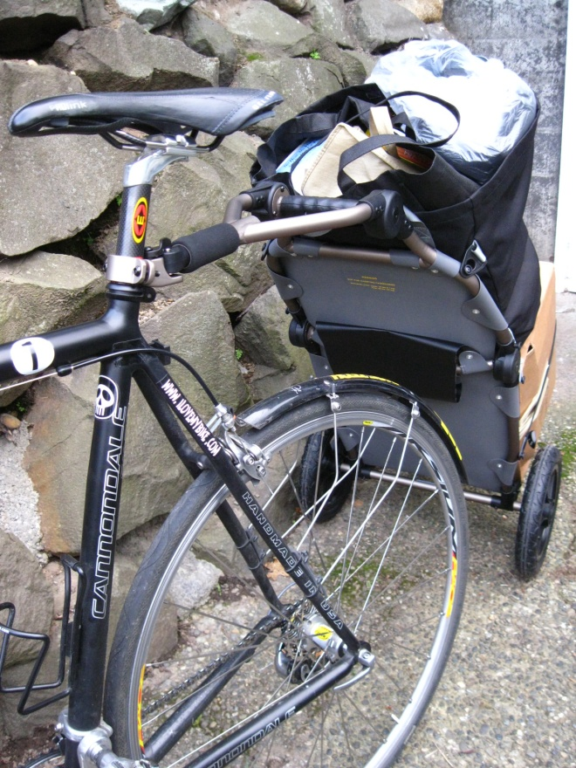
At the local grocery, the Travoy quickly detaches from your locked bike and folds into hand-truck form. It can be wheeled around while shopping to fill the cargo bag or any of the optional shopping bags Burley offers. At home or office, the trailer folds down small enough to fit inside the cargo bag, which can then be stored or hung on the wall.
If you are looking for a way to haul smaller loads and don’t want the bulk of a traditional, flat-bed trailer, the Burley Travoy would be an excellent choice. Though it can carry a hefty load, it all but disappears when folded up for storage. Order an extra hitch or two for the other bikes in your stable and the Travoy may be in use so much it will never need to be folded!
-Jef Michel Via BikeSport at ilovemybike.com

